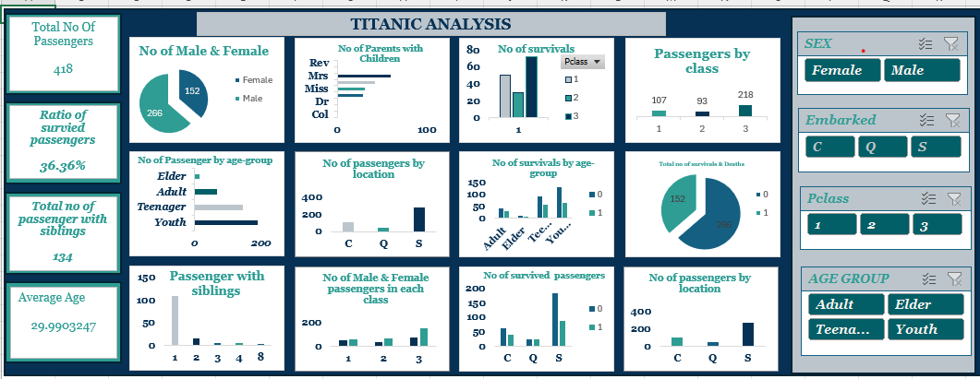
TITANIC DATA ANALYISIS REPORT

Presented by

OVIE OKPAKA

JUNE 2026

LINKEDIN:
https://www.linkedin.com/in/ovieokpaka/

INTRODUCTION
Titanic case study
Titanic was a British passenger liner, operated by the while star line, which sank in the north Atlantic Ocean on 15 April 1912 after striking an iceberg during her maiden voyage from Southampton, UK, to New York city. Of the estimated 2,224 passengers and crew aboard, more than 1500 died, which made the sinking possibly one of the deadliest for a single ship up to that time. It remains to the day the deadliest peacetime sinking of a superliner or cruise ship. The disaster drew much public attention.
I have been contacted to provide an in-depth analysis of what happened on the titanic and proffer some recommendations.
The Titanic Passenger Analysis was developed to examine passenger demographics, survival patterns, travel class distribution, embarkation locations, and family relationships among passengers aboard the Titanic.
Dataset Overview
- Total Passengers: 418
- Survival Rate: 36.36%
- Passengers with Siblings/Spouses: 134
- Average Age: 29.99 years

Techniques Applied:
- Data cleaning: Separated the first name and last name using text to column, handled missing age by finding the average of each title, created a column for age-group using ifs function
- Use of PivotTables & Pivot Charts for dynamic summarization and visualization.
- Created an interactive dashboard using slicers
- Formatted the slicers
- All charts are fully interactive, allowing real-time filtering by gender, class, age group, and embarkation port.

Findings:
- Total number of passengers who embarked was 418
- Total number of passengers who survived was 152
- Overall survival rate 36.36%
- Female passengers demonstrated significantly higher survival rates than males.
- No male passengers survived.
- Most passengers traveled alone rather than with family members.
- Southampton was the most common embarkation point.
- Gender, passenger class, and age were significant factors influencing survival outcomes.

Results:

Conclusion
The analysis highlights the strong relationship between survival rates and demographic factors such as gender, age, and passenger class. Female passengers and individuals traveling in higher classes were more likely to survive, while male and third-class passengers faced greater risks.

Recommendation:
- Prioritize vulnerable passengers during emergencies, evacuation should be based on passengers with health issues, aged passengers and children from zero (0) to fifteen (15) before anyone else.
- Improve equal access to emergency resources
- Enhance passenger safety awareness
- Conduct frequent emergency drills for crew members
- Improve data collection
- Analysis should be carried out for risk management

